***Unveiling Market Insights: Analysing Spending Behaviour And Identifying Opportunities For Growth***

Introduction

Briefly introduce the importance of understanding consumer spending behavior and the role it plays in business growth.

Mention the purpose of the analysis and its potential benefits.

Purpose

"Unveiling Market Insights: Analyzing Spending Behavior and Identifying Opportunities for Growth" in the context of wholesaling is to gain a deeper understanding of the market and consumer behavior to identify opportunities for business growth. This involves conducting a comprehensive analysis of how customers or businesses in the wholesale market are spending their resources and what factors influence their purchasing decisions.

Empathy map

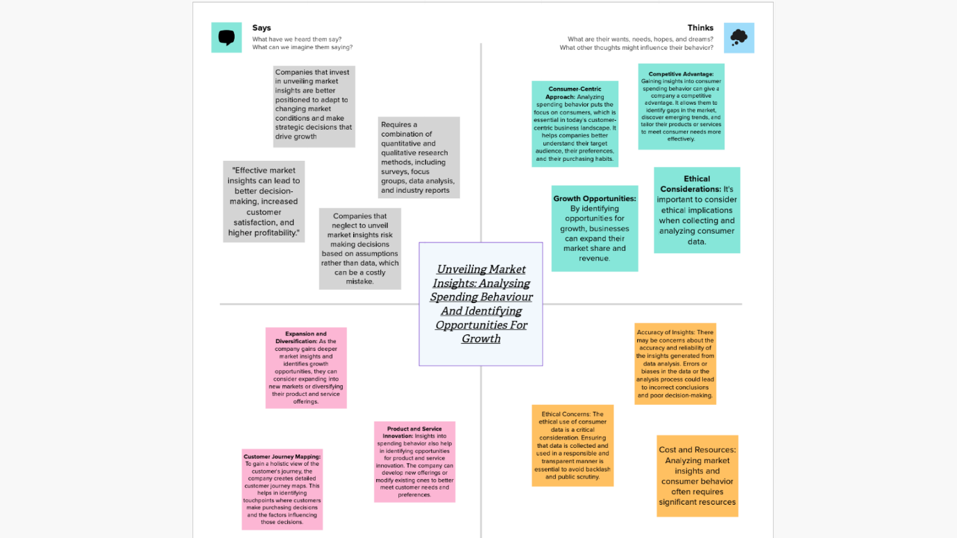

Brainstorming

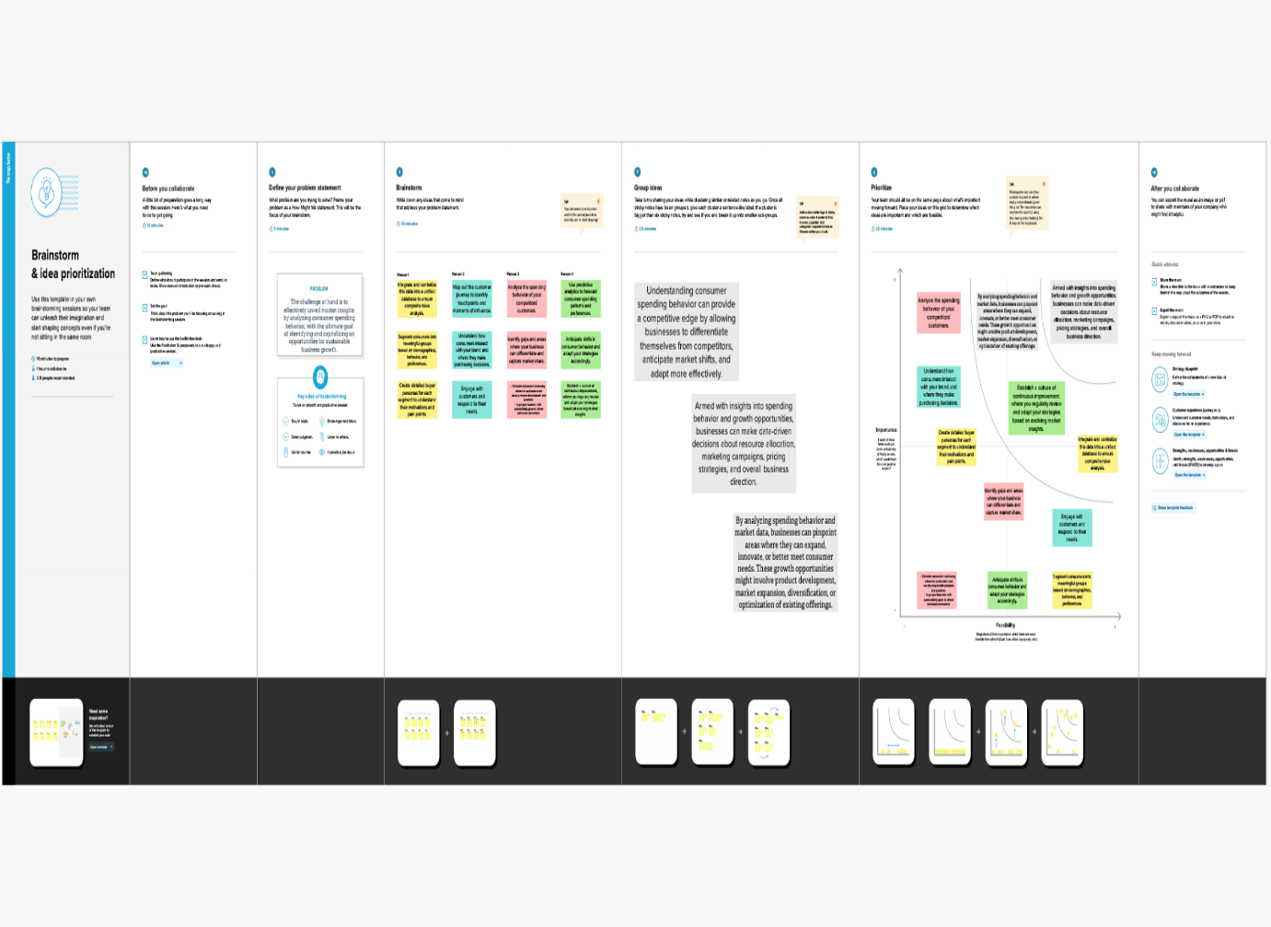

Project

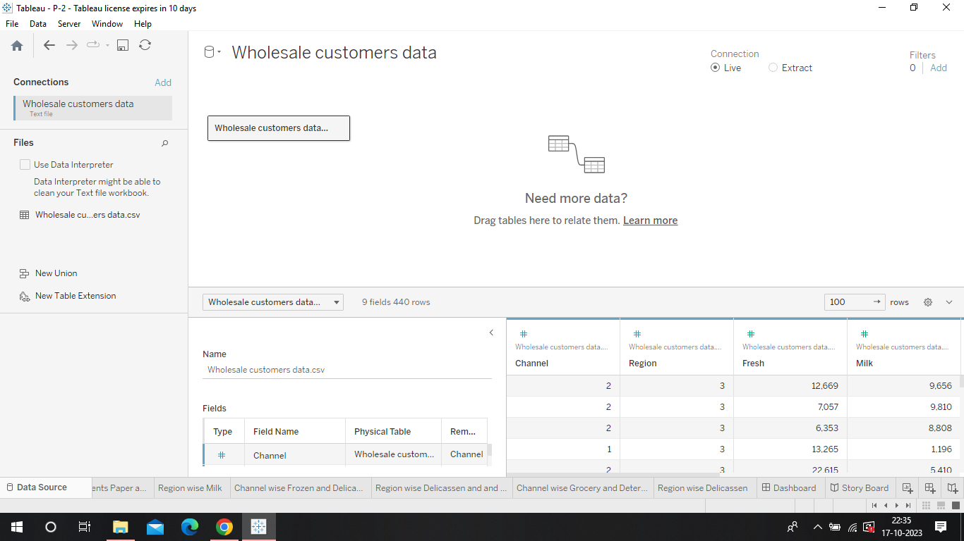

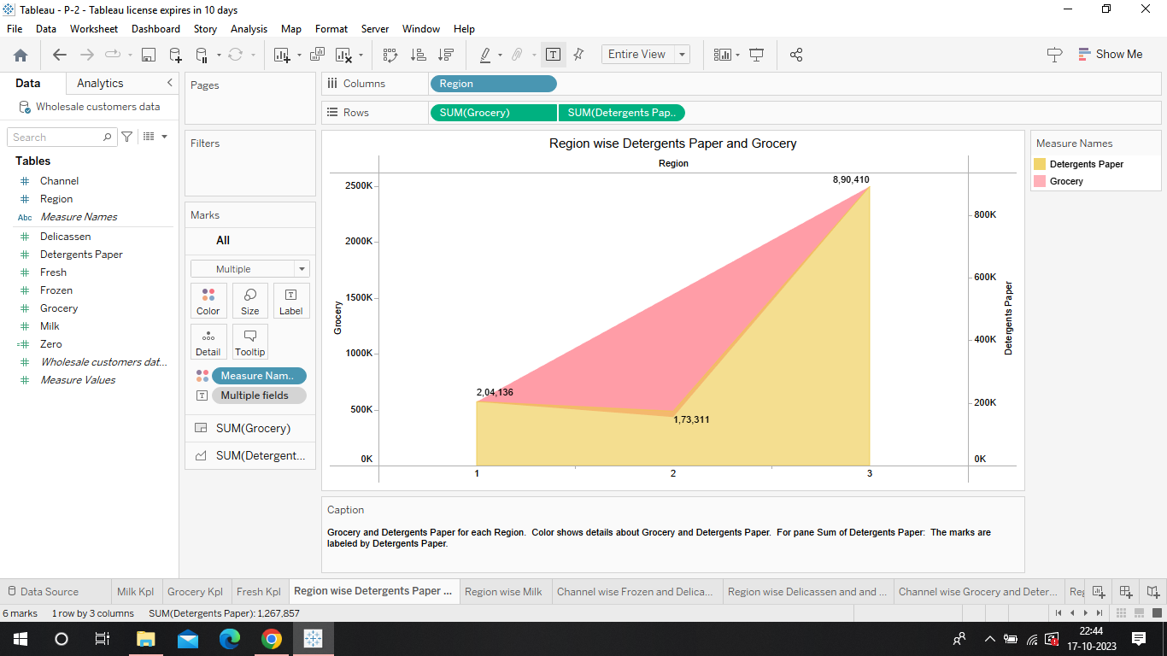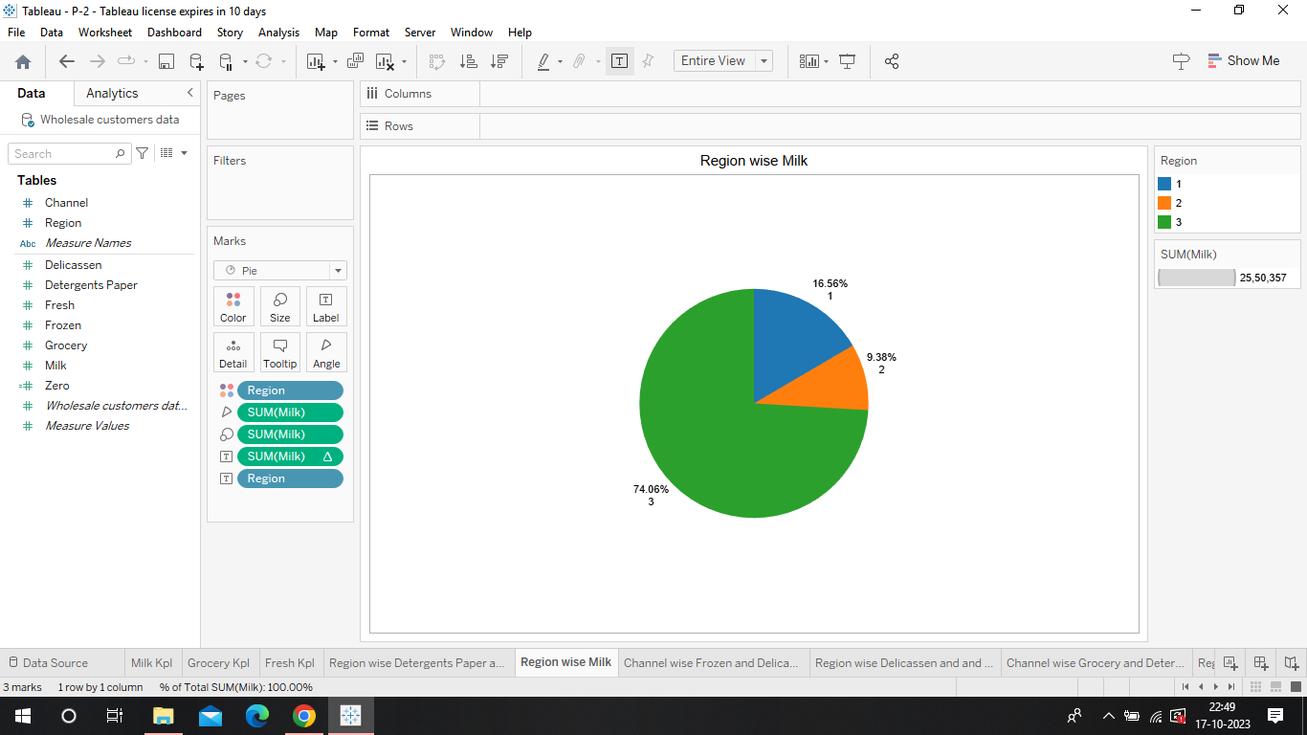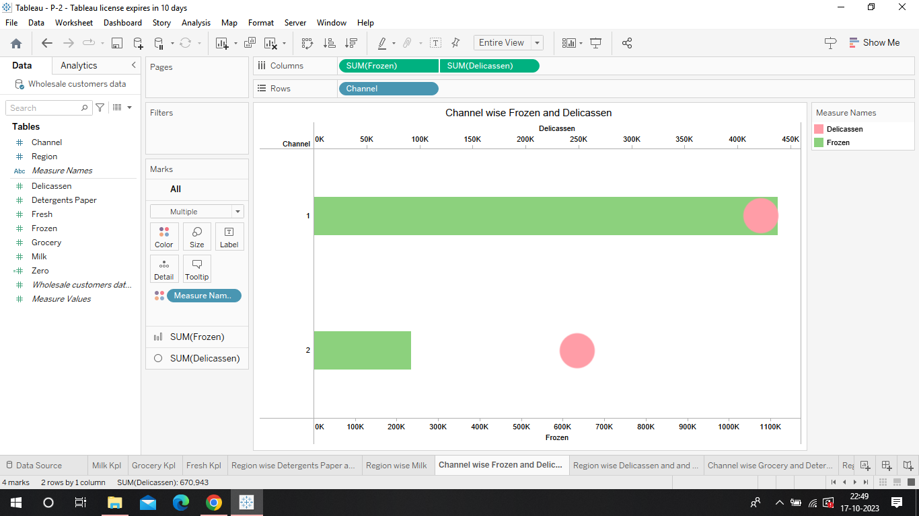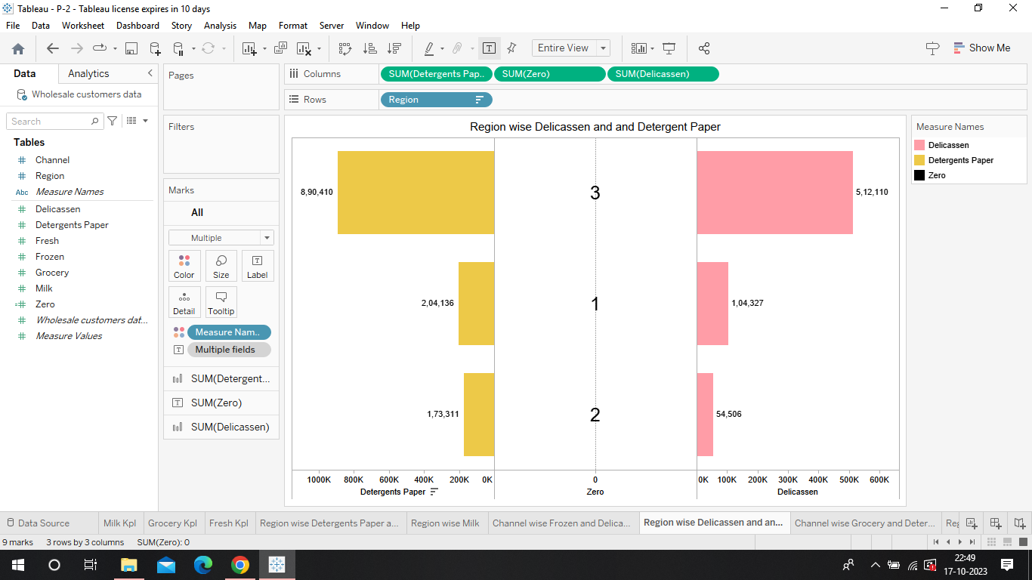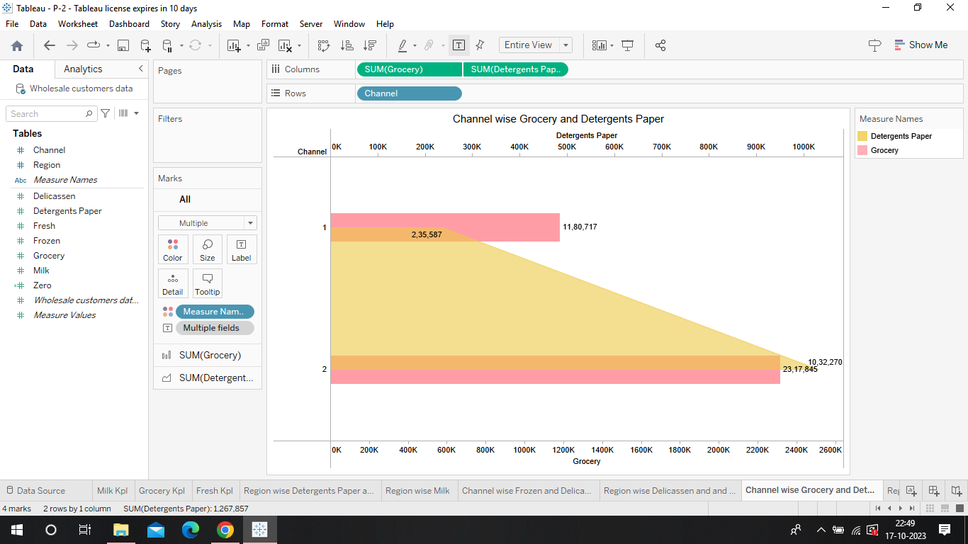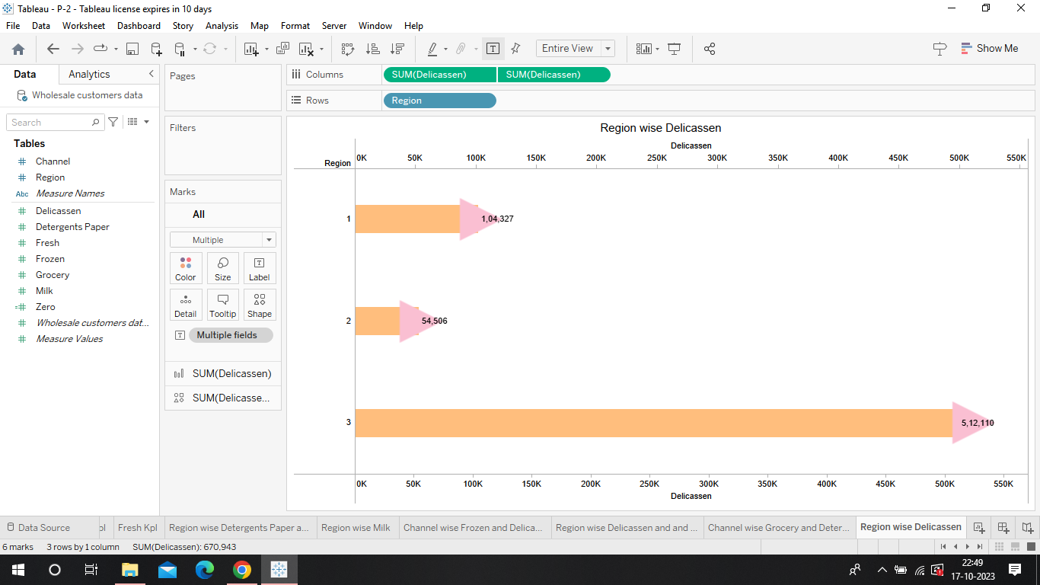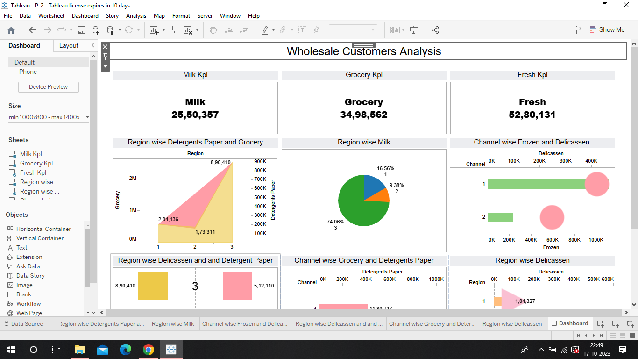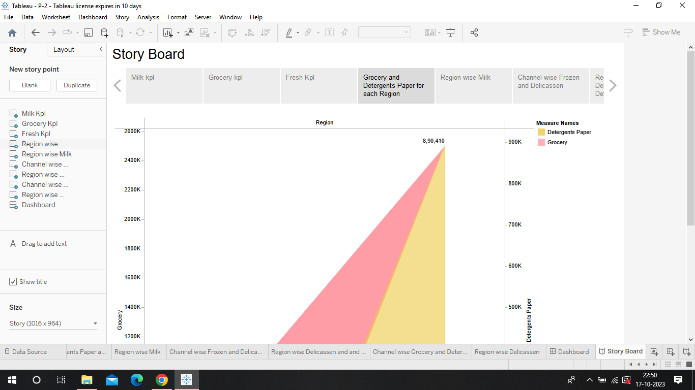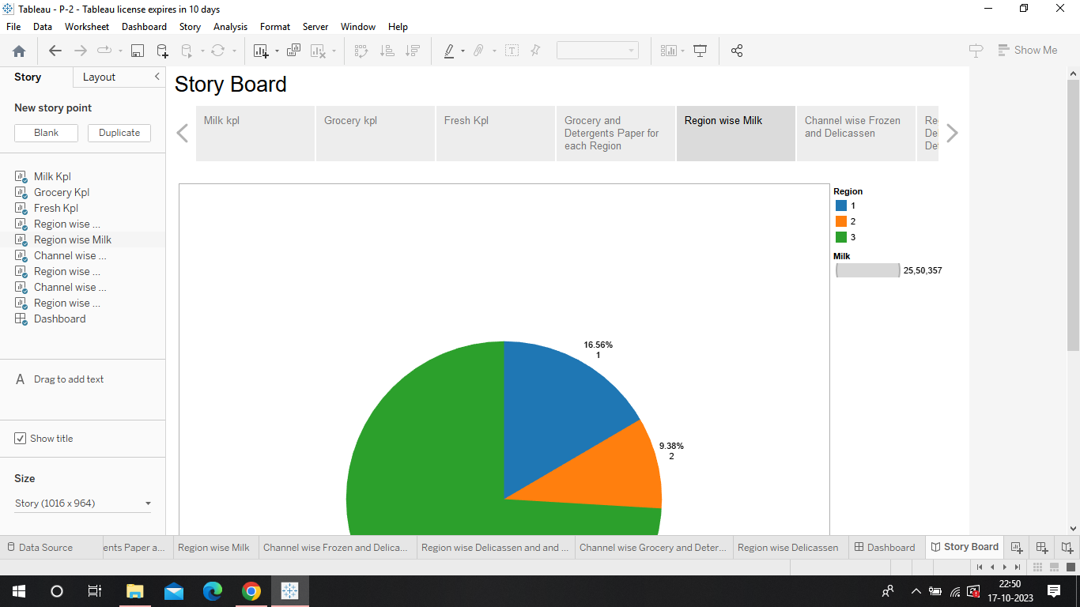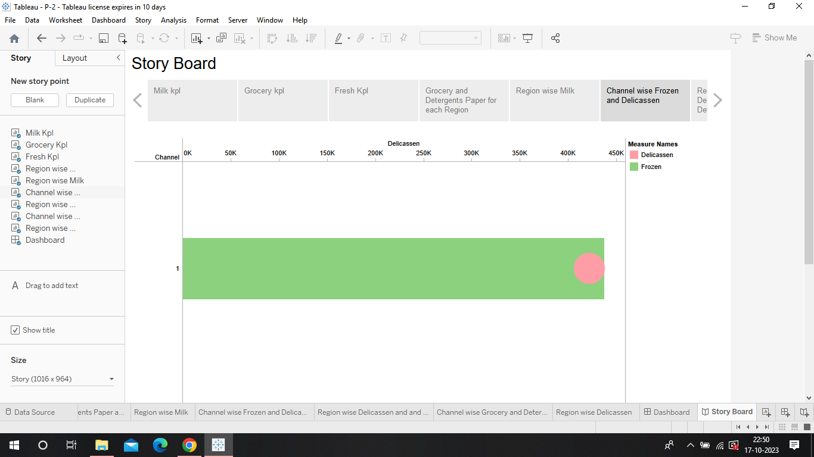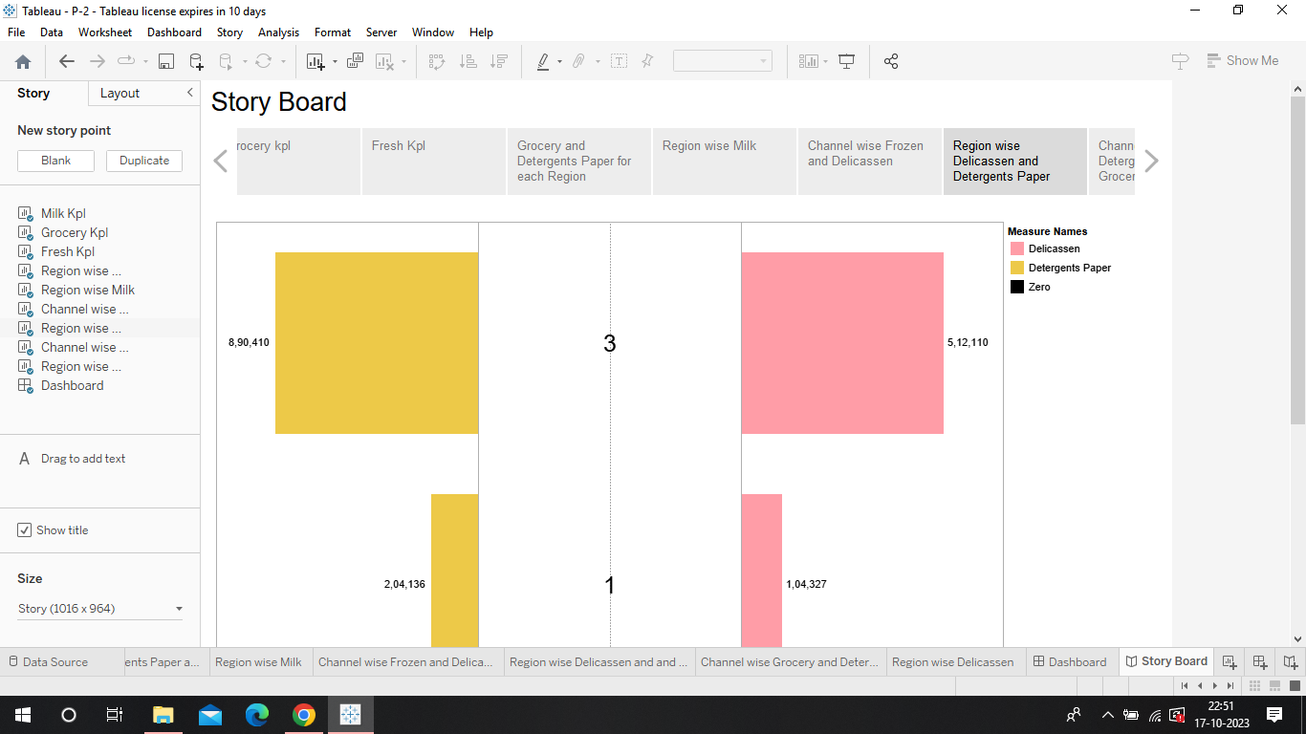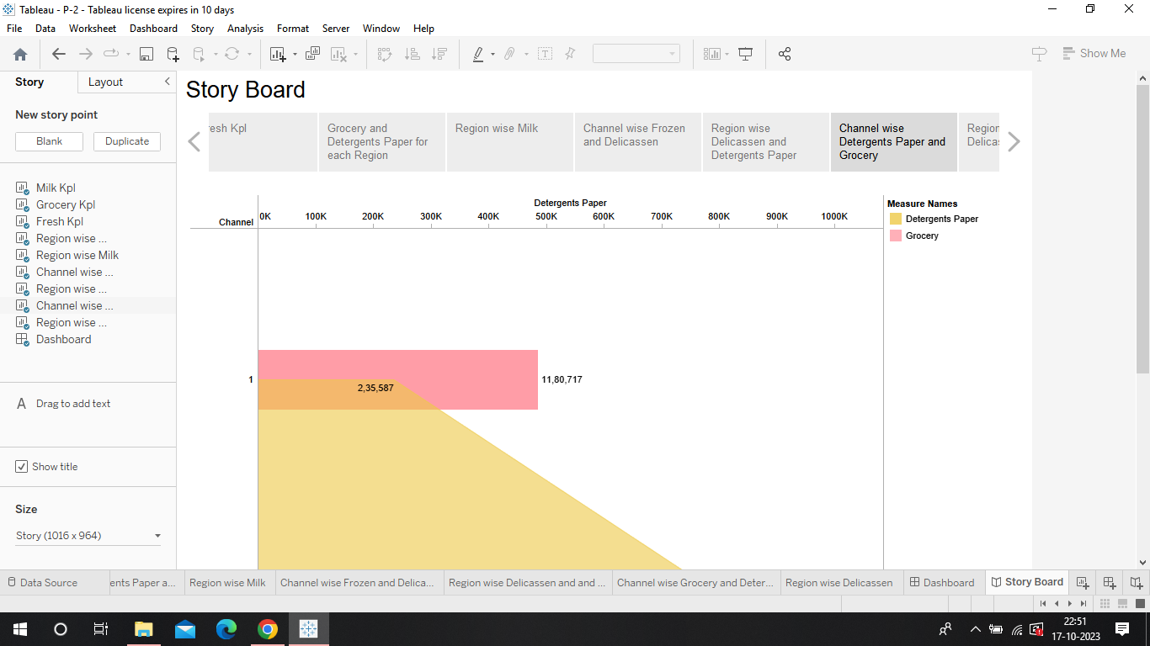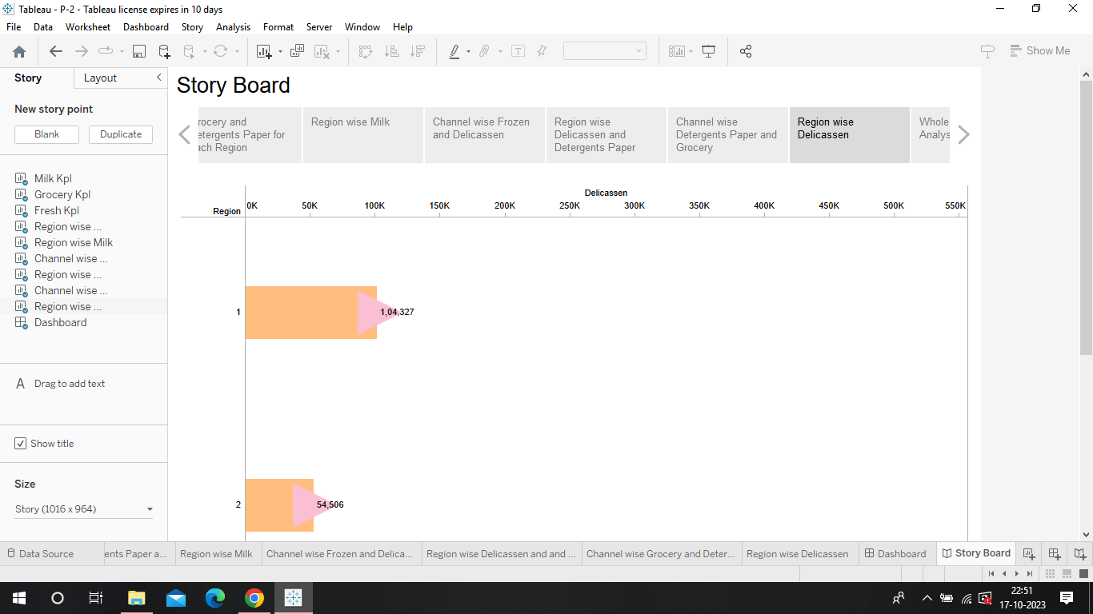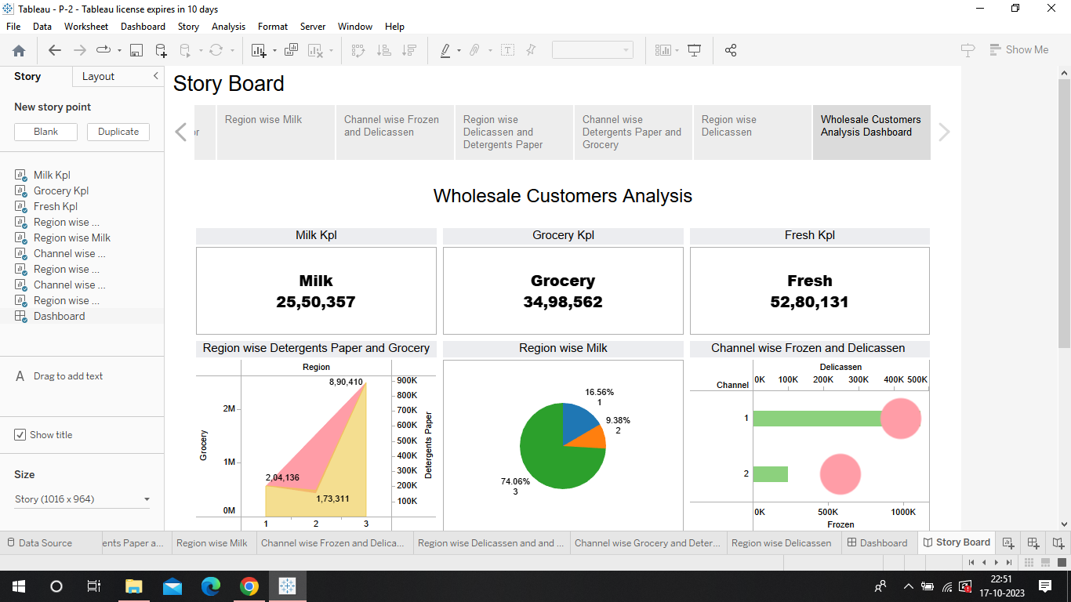

Advantages

Unveiling market insights through the analysis of spending behavior and identifying opportunities for growth offers several advantages for businesses and organizations. These insights can help inform strategic decisions, improve marketing efforts, and drive overall business success.

Disadvantages

While unveiling market insights, analyzing spending behavior, and identifying opportunities for growth can be valuable for businesses, there are some potential disadvantages and challenges associated with this process.

Conclusion

The conclusion of a report titled "Unveiling Market Insights: Analyzing Spending Behavior and Identifying Opportunities for Growth in Wholesaling" would typically summarize the key findings and insights derived from the analysis of spending behavior in the wholesale market.

Future scope

"Unveiling Market Insights: Analyzing Spending Behavior and Identifying Opportunities for Growth" is a forward-looking and data-driven approach to understanding consumer behavior and market dynamics. This approach has a significant future scope due to the continuous evolution of technology and the increasing importance of data analytics in business decision-making.

To fully realize the future scope of unveiling market insights through spending behavior analysis, businesses will need to invest in data infrastructure, analytics talent, and stay adaptable to emerging trends and technologies. This field is poised to play a pivotal role in helping businesses thrive in an increasingly data-driven and dynamic market landscape.